CSD3156 Lab8 Report

Student Name: Bryan Ang Wei Ze
Student ID: 2301397

Result 1: Please paste the screenshot in the box below.
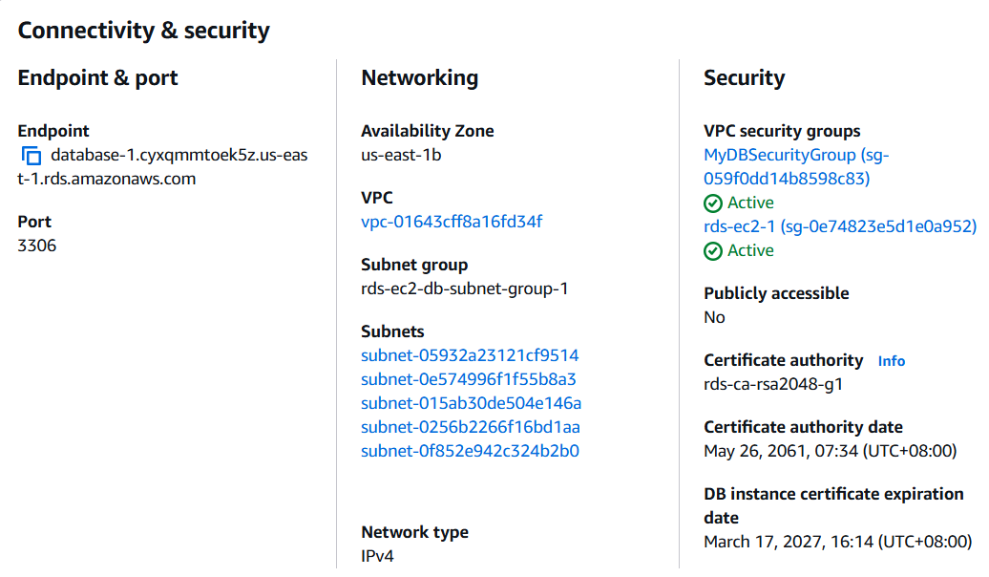

Result 2: Please paste the screenshot in the box below.
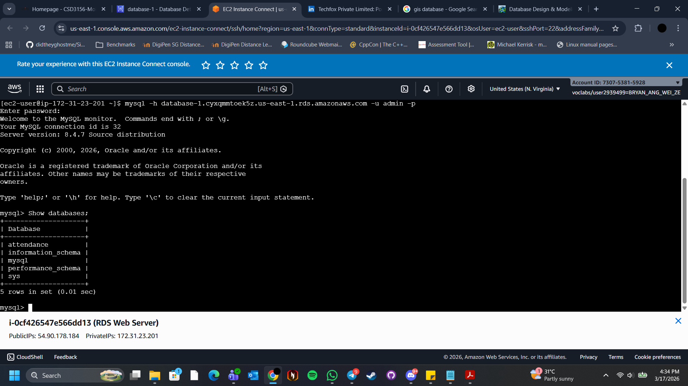

Result 3: Please paste the screenshot in the box below.
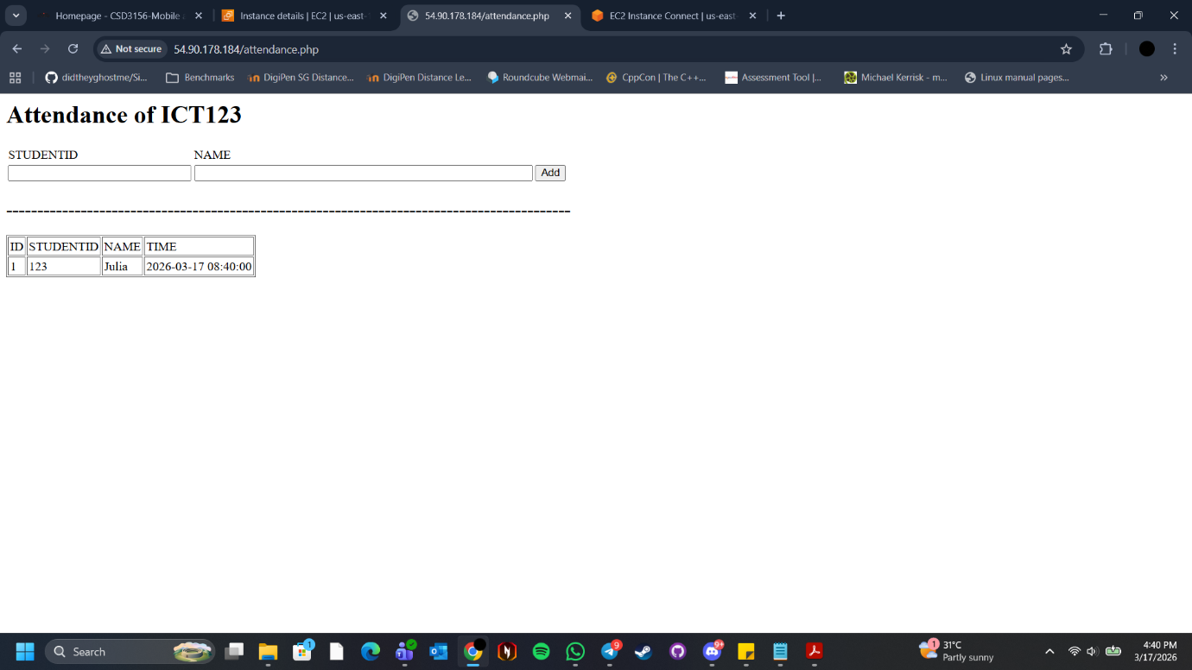

Reflection: Please add one or two lines on what you have learned.
From part 1, I have learnt how to create an Amazon RDS instance and connect it to an EC2 instance, as well as programming the web server page with PHP to make a simple web application for attendance.

From part 2, I have learnt how to create and upload a Jupyter notebook, as well as running/writting python code with Google Colab.

